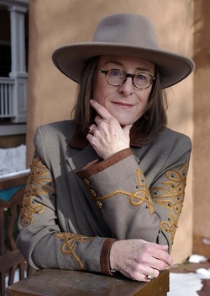
Jo-Ann Mapson is the author of eleven novels and a book of short stories. Her work is widely anthologized and her literary papers are being collected by Boston University’s Twentieth Century Author’s Collection. Hank & Chloe was her debut novel. Blue Rodeo was made into a CBS TV movie starring Kris Kristofferson. The Wilder Sisters and Bad Girl Creek were Los Angeles Times bestsellers. Solomon’s Oak won the American Library Association’s RUSA award for women’s fiction. Many of her books have been Booksense titles and Indiebound choices. Finding Casey, featuring some of the characters from Solomon’s Oak, will be published October 2012.

Core faculty and co-creator of The University of Alaska Anchorage’s low-residency MFA Program in Writing, she lives with her husband and their three Italian greyhounds in Santa Fe, New Mexico, where she is at work on a new novel. Owen’s Daughter will be published in 2014 by Bloomsbury Publishers.

